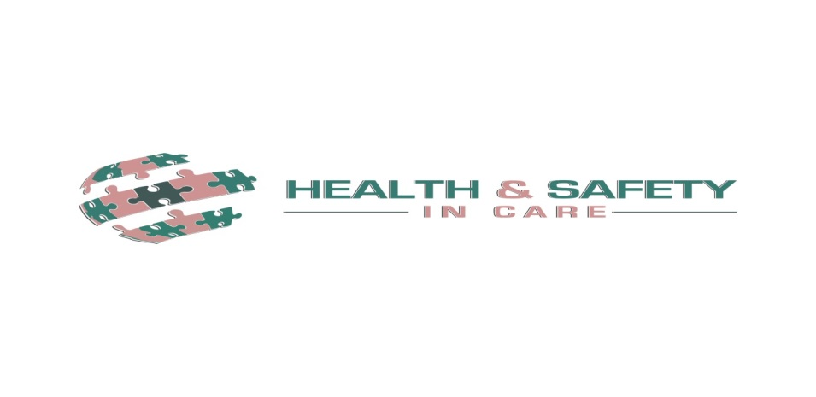
Whole School Infection Control
Policy

Contents

Introduction Page 3

Prevention and Control Page 3

What to do if you suspect an outbreak of Infection Page 5

Immunisations Page 5

Cleaning the Environment Page 6

Staff Health Page 6

Animals in School (Permanent or Visiting) Page 6

Managing Specific Infections and diseases Page 8
- Rashes and skin infection Page 8
- Diarrhoea and Vomiting Page 9
- Respiratory Infections Page 9

Appendices – List of notifiable diseases Page 10

Exclusion Table Page 10

Diarrhoea and Vomiting Outbreak Action Checklist Page 10

Introduction

The health and wellbeing of staff, pupils and visitors at our school is paramount. All school staff should take appropriate precautions to avoid infection and must understand and follow basic hygiene procedures.
Schools and nurseries are common sites for transmission of infections. Children are particularly susceptible because:
- they have immature immune systems
- have close contact with other children
- sometimes have no or incomplete vaccinations
- have a poor understanding of hygiene practices

Infections are spread in many different ways but the most important are these are through:
- Respiratory spread – coughs and sneezing
- Direct contact with infections such as impetigo and staphylococcal infections
- Gastrointestinal spread
- Blood borne virus spread

Aim of the School Infection Control Policy

We aim to ensure that all aspects of managing cases of infectious diseases in schools promote health and well-being of pupils, staff and visitors to our school. This policy takes into account local and national guidance including Government guidance (updated in February 2018): Health protection in schools and other childcare facilities.

Prevention and Control

Hand washing

Hand washing is one of the most important ways of controlling the spread of infections, especially those that cause diarrhoea and vomiting, and respiratory disease. The recommended method is the use of liquid soap, warm water and paper towels. Always wash hands after using the toilet, before eating or handling food, and after handling animals. Cover all cuts and abrasions with waterproof dressings.

Coughing and sneezing

Coughing and sneezing easily spread infections. Children and adults should be encouraged to cover their mouth and nose with a tissue. Wash hands after using or disposing of tissues. Spitting should be discouraged.

Cleaning of blood and body fluid spillages

As part of our on-going consideration to the health and welfare of the children in our care and our staff it is important that you give consideration to the following guidelines when clearing away following on from any vomiting incident or spillage of bodily fluids such as blood, urine, faeces, mucus. If this process is carried out effectively it will have a considerable impact on the containment of the viruses that cause vomiting and diarrhoea.

It is important that you first give consideration to the child that is unwell – and ensure that they are being cared for effectively. If appropriate, clear the area of other children and staff to ensure that their welfare is being considered.

You should then:
- Prepare yourself – using disposable aprons & gloves from the bodily fluid pack
- Using disposable paper towels/roll and the absorbent crystals within the kit, gather the bodily fluid into an area – soaking up the liquid using the paper towels and crystals.
- Place all into a clinical waste bag – ‘yellow bag’
- Watch out for soft furnishings that may have been contaminated. These must be sent to the laundry for a high temperature wash
- Dispose of the aprons and gloves by placing in a yellow bag and firmly tying the top
- Mark the affected area with chairs/sign and call a member of the housekeeping team to deep clean the area
- Leave the clinical waste bag in the marked off area (without contaminating it) for disposal by the housekeeping team
- Wash your hands/arms thoroughly using an anti-bactericide soap or soap followed by hand gel to eliminate any possibility of cross infection

Clinical Waste

Always segregate domestic and clinical waste, in accordance with local policy. Used nappies/pads, gloves, aprons and soiled dressings should be stored in correct clinical waste bags in foot-operated bins. All clinical waste must be removed by a registered waste contractor. All clinical waste bags should be less than two-thirds full and stored in a dedicated, secure area while awaiting collection.

Sharps Disposal

Sharps should be discarded straight into a sharps bin conforming to BS 7320 standards. Sharps bins must be kept off the floor (preferably wall mounted) and out of reach of children.

Sharps injuries and bites

If skin is broken, encourage the wound to bleed/ wash thoroughly using soap and water. Contact the School Nurse, or go to A&E immediately.

Vulnerable children

Some medical conditions make children vulnerable to infections that would rarely be serious in most children; these include those being treated for leukaemia or other cancers, on high doses of steroids and with conditions that seriously reduce immunity. Our School Nurse will be aware of these children. These children are particularly vulnerable to chickenpox, measles or parvovirus B19 and, if exposed to either of these, the parent/carer should be informed promptly and further medical advice sought.

https://www.gov.uk/government/publications/health-protection-in-schools-and-other-childcare-facilities/chapter-3-prevention-and-control

What to do if you suspect an outbreak of Infection
An outbreak or incident may be defined as:
- an incident in which two or more people experiencing a similar illness are linked in time or place
- a greater than expected rate of infection compared with the usual background rate for the place and time where the outbreak has occurred
For example:
- 2 or more cases of diarrhoea and/or vomiting which are in the same classroom, shared communal areas or taking part in the same activities
- higher than usual number of people diagnosed with scabies
- higher than usual number of people diagnosed with scarlet fever
- two or more cases of measles at the school or other childcare setting

The Head Teacher or Deputy Head Teacher will contact the local health protection team as soon as they suspect an outbreak to discuss the situation and agree if any action is needed:

PHE Cheshire and Merseyside Health Protection Team,
Suite 3B 3rd Floor Cunard Building, Water Street,
Liverpool,
L3 1DS

Phone: 0344 225 0562 option 1
https://www.gov.uk/government/publications/health-protection-in-schools-and-other-childcare-facilities/chapter-4-what-to-do-if-you-suspect-an-outbreak-of-infection
Immunisation
The immunisation status of pupils is checked on admission by the office manager. Parents should be encouraged to have their child immunised and any immunisation missed or further catch-up doses organised through the child’s GP.
The national immunisation schedule changes periodically so it is important to check the NHS Choices website for up to date details.

Staff immunisation
It is important that all staff are up to date with the current immunisation (check NHS Choices website). In addition to this, the following risk areas should be considered:

Hepatitis B
Hepatitis B vaccine is not recommended for routine school or nursery contacts of an infected child or adult. Hepatitis B vaccine is, however, recommended for staff who are involved in the care of children with severe learning disability or challenging behaviour, and for these children, if they live in an institutional accommodation. In such circumstances it is the responsibility of the employer to finance the vaccine programme.

Rubella
Women of childbearing age should check with their GP that they are immune to the rubella (German measles) virus. Those who are not immune should be immunised with MMR vaccine. The vaccine should not be given during pregnancy.

https://www.gov.uk/government/publications/health-protection-in-schools-and-other-childcare-facilities/chapter-5-immunisation
Cleaning the Environment
Cleaning of the environment, including toys and equipment, is an important function for the control of infection. The school policy is to purchase toys with a washable surface wherever possible. Staff working in the EYFS classroom will wipe toys with antiseptic wipes on a daily basis and equipment will be washed with hot soapy water at least half-termly.

Cleaning of the environment

Cleaning of the environment, including toys and equipment, will be supplemented by a cleaning schedule agreed with our school cleaning team. To prevent cross-contamination between surfaces a proper colour coding system will be used to increase general hygiene and cleanliness.
- Red mops used in Toilets/washrooms
- Yellow cloths used in hand wash basins and sinks
- Blue mops for classrooms, offices and corridors
- Green mops and cloths in kitchens
Disposable cloths will be used wherever possible.

Personal protective equipment (PPE)

Disposable non-powdered vinyl or latex-free CE-marked gloves and disposable plastic aprons must be worn where there is a risk of splashing or contamination with blood/body fluids (for example, nappy or pad changing). Goggles should also be available for use if there is a risk of splashing to the face. Correct PPE should be used when handling cleaning chemicals.

https://www.gov.uk/government/publications/health-protection-in-schools-and-other-childcare-facilities/chapter-6-cleaning-the-environment
Staff Health
All staff should undergo a full occupational health check before starting employment; this includes ensuring they are up to date with immunisations, including Measles, Mumps, Rubella (MMR).
Female Staff – Pregnancy
If a pregnant woman develops a rash or is in direct contact with someone with a potentially infectious rash, this should be investigated according to PHE guidelines by a doctor.
https://www.gov.uk/government/publications/health-protection-in-schools-and-other-childcare-facilities/chapter-7-staff-health
Animals in School (Permanent or Visiting)
Animals may carry infections, so hands must be washed after handling any animals. Health and Safety Executive (HSE) guidelines for protecting the health and safety of children should be followed. Contact with animals can pose a risk of infection including gastro-intestinal infection, fungal infections and parasites. Some people, such as pregnant women and those with a weakened immune system, are at greater risk of developing a severe infection.

Animals
Staff will ensure animals’ living quarters are kept clean and away from food areas. Waste will be disposed of regularly, and litter boxes not accessible to children. Children will not play with animals unsupervised.
Reptiles are not suitable as pets in schools and nurseries, as all species carry salmonella.
https://www.gov.uk/government/publications/health-protection-in-schools-and-other-childcare-facilities/chapter-8-pets-and-animal-contact

Managing Specific Infections and diseases
Rashes and Skin Infections
Children with rashes should be considered infectious and assessed by their doctor  Infection or complaint | Recommended period to be kept away from school, nursery | Comments
Athlete’s foot | None | Athlete’s foot is not a serious condition. Treatment is recommended
Chickenpox | Until vesicles have crusted over | See: Vulnerable Children and Female Staff – Pregnancy
Cold sores, (Herpes simplex) | None | Avoid kissing and contact with the sores. Cold sores are generally mild and self-limiting
German measles (rubella) | Four days from onset of rash | Preventable by immunisation
Hand, foot and mouth | None | Contact your local HPT if a large number of children are affected. Exclusion may be considered in some circumstances
Impetigo | Until lesions are crusted and healed, or 48 hours after starting antibiotic treatment | Antibiotic treatment speeds healing and reduces the infectious period
Measles | Four days from onset of rash | Preventable by vaccination
Molluscum Contagiosum | None | A self-limiting condition
Ringworm | Exclusion not usually required | Treatment is required
Roseola (Infantum) | None | None
Scabies | Child can return after first treatment | Household and close contacts require treatment
Scarlet Fever | Child can return 24 hours after starting appropriate antibiotic treatment | Antibiotic treatment is recommended for the affected child
Slapped cheek/fifth disease. Parvovirus B19 | None (once rash has developed) | See: Vulnerable Children and Female Staff – Pregnancy
Shingles | Exclude only if rash is weeping and cannot be covered | Can cause chickenpox in those who are not immune, i.e. have not had chickenpox. It is spread by very close contact and touch. If further information is required, contact your local PHE centre. See: Vulnerable Children and Female Staff – Pregnancy
Warts and Verrucae | None | Verrucae should be covered in swimming pools, gymnasiums and changing rooms
Diarrhoea and Vomiting
Infection or Complaint | Recommended period to be kept away from school, nursery | Comments
Diarrhoea and / or vomiting | 48 hours from last episode of diarrhoea or vomiting
E. coli O157 VTEC Typhoid | Should be excluded for 48 hours from the last episode of diarrhoea. Further exclusion may be required for some children until they are no longer excreting | Further exclusion is required for children aged five years or younger and those who have difficulty in adhering to hygiene practices.  Children in these categories should be excluded until there is evidence of microbiological clearance. This guidance may also apply to some contacts who may also require microbiological clearance. Please consult your local PHE centre for further advice.
Cryptosporidiosis | Exclude for 48 hours from the last episode of diarrhoea | Exclusion from swimming is advisable for two weeks after the diarrhoea has settled.

Respiratory Infections
Infection or Complaint | Recommended period to be kept away from school, nursery or child minders | Comments
Flu (influenza) | Until recovered
Tuberculosis | Always consult your local PHE Centre | Requires prolonged close contact for spread
Whooping Cough (Pertussis) | Five days from starting antibiotic treatment, or 21 days from onset of illness if no antibiotic treatment | Preventable by vaccination. After treatment, non-infectious coughing may continue for many weeks. Your lock PHE centre will organise any contact tracing necessary

https://www.gov.uk/government/publications/health-protection-in-schools-and-other-childcare-facilities/chapter-9-managing-specific-infectious-diseases

Policy Development and Review
This policy document was produced in consultation with the entire school community, including pupils, parents, school staff including the catering staff and Governors.
This document is freely available to the entire school community. It has also been made available in the school newsletter, web-site and prospectus.
This policy will be reviewed on an annual basis.

Review date………………………………….

Signed………………………………………………Head Teacher

Date……………………………..

Appendices
https://www.gov.uk/government/publications/health-protection-in-schools-and-other-childcare-facilities/appendices
Exclusion Table
https://assets.publishing.service.gov.uk/government/uploads/system/uploads/attachment_data/file/691091/Exclusion_table.pdf
Appendix 3: Diarrhoea and Vomiting Outbreak Action Checklist
https://assets.publishing.service.gov.uk/government/uploads/system/uploads/attachment_data/file/625991/Appendix_3.pdf

