Risk Assessment – Specific Activity/Situation
Risk Assessment Reference No: | MO-26-10_19

Workplace Activity: | Using petrol strimmer | Date: | October 2019

Persons at Risk- Affected by Activity: | Site Team | Number | 1
Any Vulnerable Persons Affected by Activity: | Persons with restricted mobility | Number | TBC

Setting the Scene:

Trimming edges of playground, pathways and borders with a petrol strimmer.

Potential Hazards |  | Assessment of Risk
Ref. |  | Low | Med | High
1. | Physical injury caused by manual handling |  | X
2. | Slips and trips on uneven ground or algae covered floor surfaces |  | X
3. | Entrapment with moving parts of machine |  | X
4. | Cuts to fingers when installing the nylon line |  | X
5. | Fire caused when filling fuel/static electricity | X
6. | Injury through flying stones or sharp objects such as plastic toys |  |  | X
7. | Zoonotic diseases, including toxocariasis- a likely source is animal faeces being scattered during cutting. | X
8. | White knuckle syndrome, vibration white finger (VWF) or Secondary Raynaud's disease | X
9. | Noise induced hearing loss |  | X
10.

Existing Control Measures
1, MO attend manual handling training every 3 years.
- small quantities of fuel are stored in the external storeroom – 5 litre containers.
- MO is advised to inform their immediate line manager if they suffer from MSD’s.
- The equipment is only use on grass surfaces – not on paving of hard surfaces.
2. MO will check the site prior to beginning activity to assess conditions.
- Mark danger areas if necessary.
- The site will be kept tidy and clear of loose materials and tools
- MO to wear good quality safety boots with non-slip sole
3. MO to make full safety checks before operation to make sure the cutter is working at its operational best.
- Check that all cutting heads are in good order and properly fixed.
- Make sure kill switch and dead man’s throttle are operating properly.
- The strimmer must be maintained in good working order.
- MO to stop using machine immediately if any fault is detected.
- MO to inspect strimmer regularly to ensure efficient cutting.
4. PPE will be worn including safety gloves, goggles, hard hat and safety boots.
- The MO will not use the strimmer during normal school hours. If a pedestrian is within 10 metres distance the strimmer will be switched off.
- A First Aid kit present. The nylon line will only be changed when power to strimmer has been isolated.
- The MO will take extra care when working on slopes, (no work on slopes greater than 45°) and on uneven ground.
5. Fuel must be in approved containers, up to 5 litres in plastic and 10 litres in metal jerry can.
- Refuel only when strimmer has cooled in a ventilated area.
- Refuelling to occur 3 metres away from ignition source, work area and water course or drain.
- Spill kit must be present in area used when refilling.
- All fuel caps are kept securely in place except during the refuelling operation.
- Excess fuel is stored in the secure external storeroom – no more that 5 litres kept in storage.
- Strimmer is stored upright when not in use to reduce risk of spillages.
- Flammable signs are displayed outside store room. No smoking is permitted on site.
6. Other pedestrians should be at least 5 metres away from the strimmer in operation.
- The working area is taped or coned off to prevent members of the public from being endangered.
- MO should use a visor or goggles kite marked for impact protection.
- Any strimmer guards present must be in place and in good working order
- MO will carry out visual inspection of area to be worked in prior to commencing the cutting process. Any small toys or obvious stones will be removed from the area.
- Strimming will only be carried out in daylight hours.
- The machine will not be used when it is wet.
7. Suitable visor with eye shield/glasses should be worn by operator.
- Do not use the strimmer above shoulder height.
- Wash hands thoroughly at end of process or before eating.
- If nausea, lethargic, flu-type symptoms are experienced, you should seek medical attention.
8. Strimmer will be well maintained and vibration-dampeners inspected before operation.
- Manufacturer’s instructions will show maximum usage times for an optimally maintained strimmer.
- Take regular breaks e.g. 10 minutes between tank fills and 30 minutes between 3 tank fills.
9. Always were hearing defenders when using the strimmer.

Initial Assessment of Overall Risk | Low |  | Medium |  | High | X

RISK RATING = SEVERITY x LIKELIHOOD
Rating | SEVERITY of injury/disease | LIKELIHOOD of occurrence
HIGH | Fatality; major injury or illness causing long term disability | Certain or near certain to occur
MEDIUM | Injury or illness causing short term disability | Reasonably likely to occur
LOW | Other injury or illness | Unlikely to occur

ADDITIONAL CONTROL MEASURES - (IF APPLICABLE) | PERSON RESPONSIBLE  FOR IMPLEMENTATION | COMPLETION  DATE
Check that the site team have been issued with gloves, safety glasses and helmets for use when using the strimmer. | Site Manager

RESIDUAL ASSESSMENT OF OVERALL RISK | LOW |  | MEDIUM | X | HIGH

Note: Re-assessment required if overall residual risk is High

ADDITIONAL INFORMATION:
(Notes, comments, further details, outline procedures, safe systems of work, standards, drawings, etc.)

1. Wear the Right Protective Gear
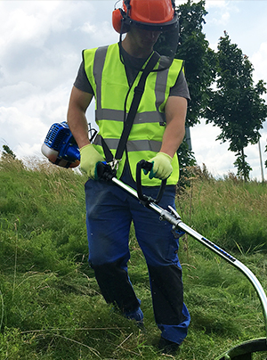
With a trimming line that revolves at up to 3,000 revolutions per minute, it’s worth taking your personal protective equipment seriously. Eye and face protection is a must. A pair of tough gloves and sturdy shoes is highly recommended. Strimmers can be very noisy, so get some ear defender or plugs. Regardless of the weather, wear full length trousers and avoid loose fitting clothes.

2. Expect Flying Debris
Even the best kept gardens can have nasty surprises lurking just beneath the surface. Pieces of debris, such as a stone, could easily be flung towards a window or unsuspecting person’s eyes.Check the garden for surprises before you turn on the strimmer. 5 minutes of checking for obstructions could save you from a broken window or worse.

It really can’t be said enough, accidentally coming into contact with the trimming line will cause some serious damage. If you’re wearing the right clothes, you’ll minimise the risks, but just be aware that while the strimmers turned on, you should be nowhere near the spool. If you do have to perform any maintenance on the line end, make sure the tool has been switched off and has cooled down before you attempt the work.

Be careful around fences, plant pots, garden walls and sculptures - hitting hard things will mean you’ll go through trimmer line really quickly as well as potentially take a chunk out of whatever you hit. Clear you garden of furniture, ornaments etc before you start your work.

Be Cautious of Liquid Fuels & Fumes
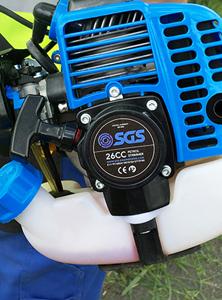
Wherever there’s a liquid fuel, there’s going to be exhaust emissions. Carbon-monoxide is very poisonous and invisible, so never use your strimmer in an enclosed space where gases can collect. If your strimmer is making excessive fumes, you might need to do some maintenance and adjust the carburettor’s air intake. Store your petrol or fuel mix somewhere in a secure external shed away from anything that might cause a spark. Allow an engine to completely cool down before you try and refuel a petrol powered tool.

Edging a Border
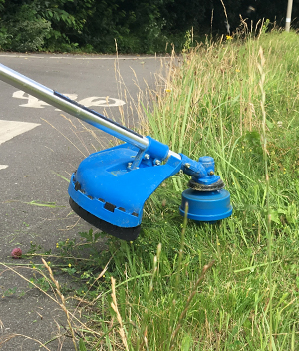
Where two surfaces are basically flush, you’ll find that edging gives you that sharp, clean cut finish. You might want to use this technique between your lawn and playground or around flower bed borders. To achieve this finish, keep your strimmer spool flat and parallel to the ground. Find your cut height, get into a comfortable working position and then simply walk into the cut path. Keep a firm grip at a uniformed height for the best results. Expect dirt, stones and debris to be thrown around when you attempt this cutting technique.

Tapering Up to Walls, Fences or Around Trees
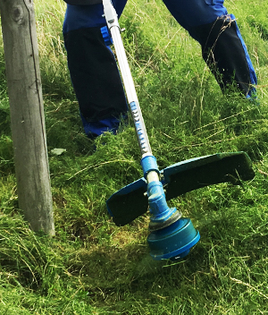
Tapering gives a gradual, fading grass effect that looks particularly attractive around obstacles, giving a more natural feel than the strong parallel cut you get from edging. Instead of angling the trimmer line flat (like you do when edging) hold your strimmer at a slight angle. Pitch the tip of the cutting line towards the object you’re trimming around - you’ll cut less grass as you move around the obstacle, but a tapered edge means you won’t end up with an unattractive channel of grass between where you’ve mowed and your obstruction. Blend the edge with the height of your mowed grass for a clean but natural looking finish.

cything Longer Grass & Weeds
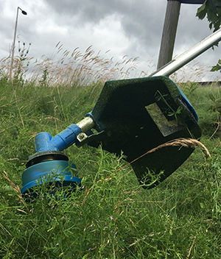
Some obstacles can’t be easily walked around, particularly when working in longer grass. You shouldn’t attempt scything unless you have a powerful strimmer - preferably a petrol strimmer. To trim longer grass and weeds, or to cut around a more difficultly placed obstacle, take a strong stance and bring the tool in and out of the cutting area in a shallow “U” shape. You can overlap your scythes for a more even cut, or space them out a bit for a natural wavy effect.

Risk Assessment Circulation List (tick box)
Employees |  |  | Management |  |  | Contractors
Other – Specify:
Signature of responsible person: |  |  |  |  |  | Date:
Assessor: | Adele Partridge, CMIOSH MIIRSM |  |  | Signature: |  | 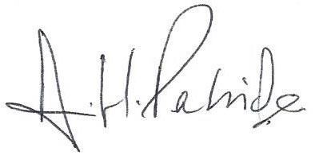
Date Assessed: | October 2019 |  |  | Review Date: |  | October 2019

RISK ASSESSMENT REVIEW - COMMENTS
Date:
Reason for Review
Reviewed By: |  | Signature:

RISK ASSESSMENT REVIEW - COMMENTS
Date:
Reason for Review
Reviewed By: |  | Signature:

